**Important FrontEnd with BackEnd**

**Ensuring patients receive care when they return for multiple visits.**

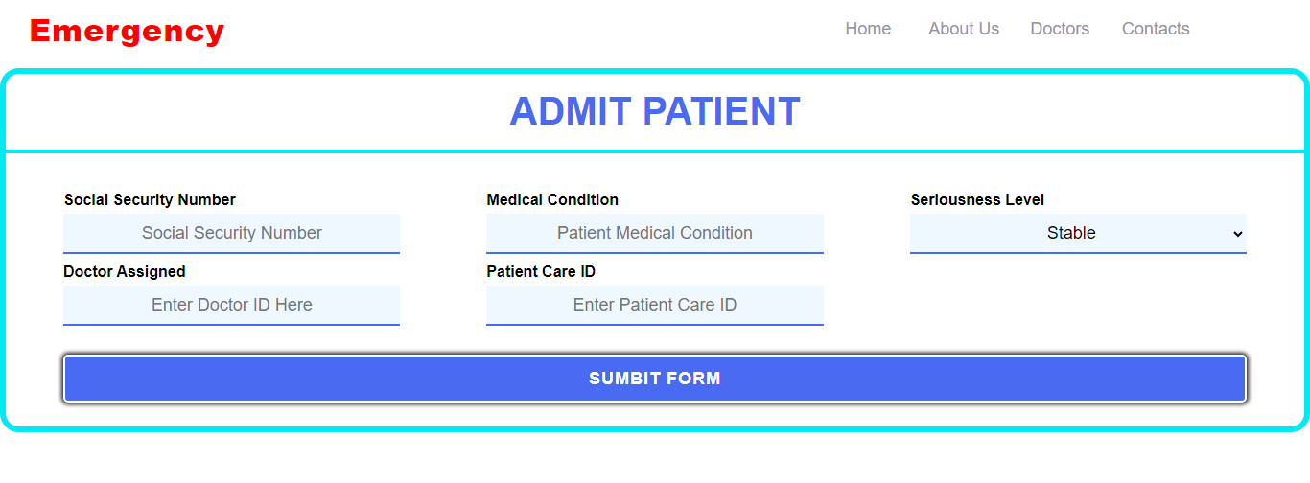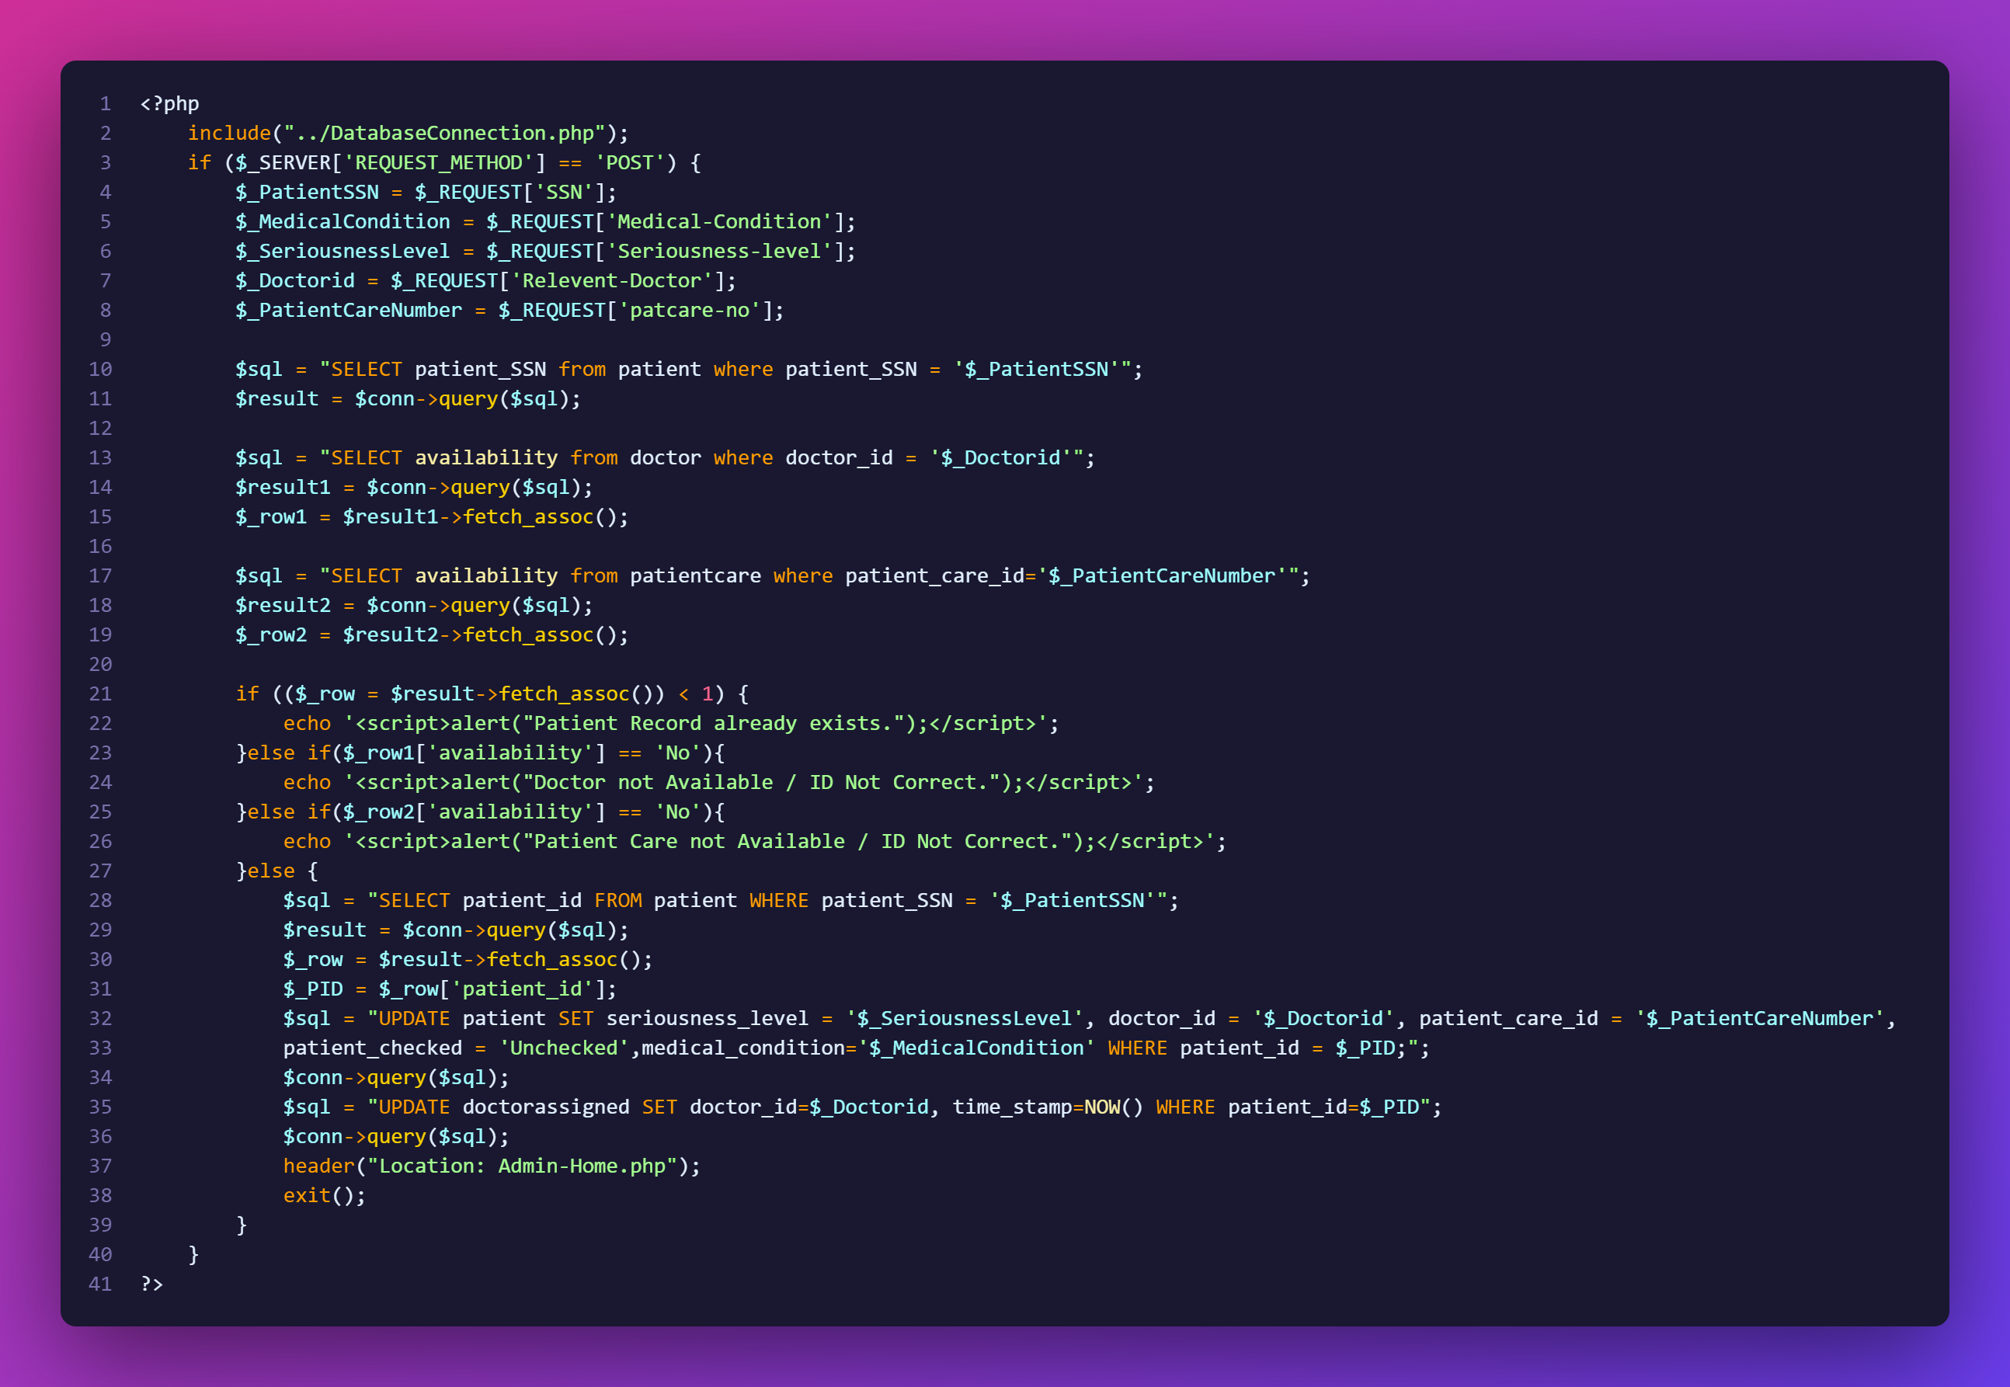

**Deleting Whole Patient Record**

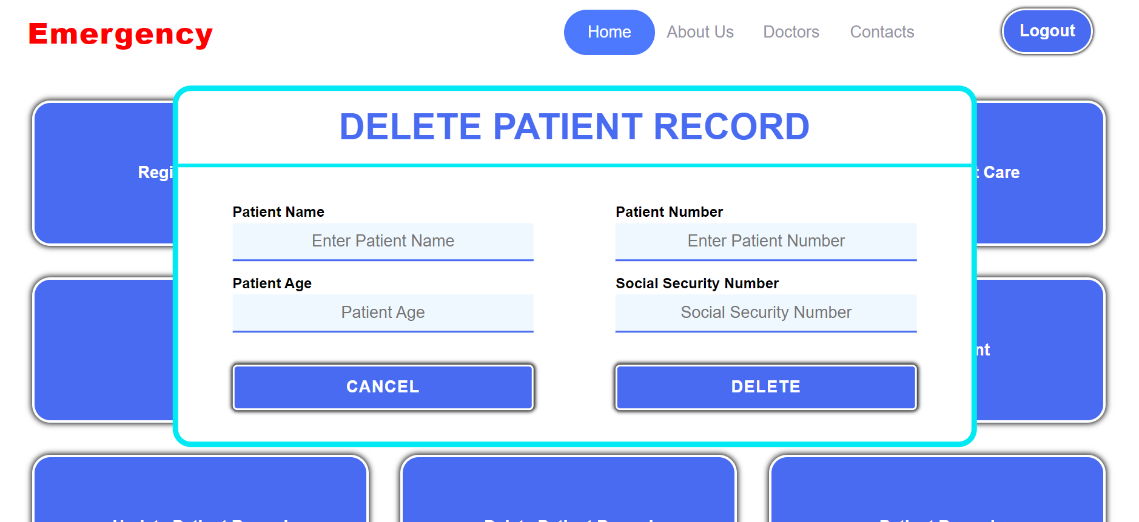

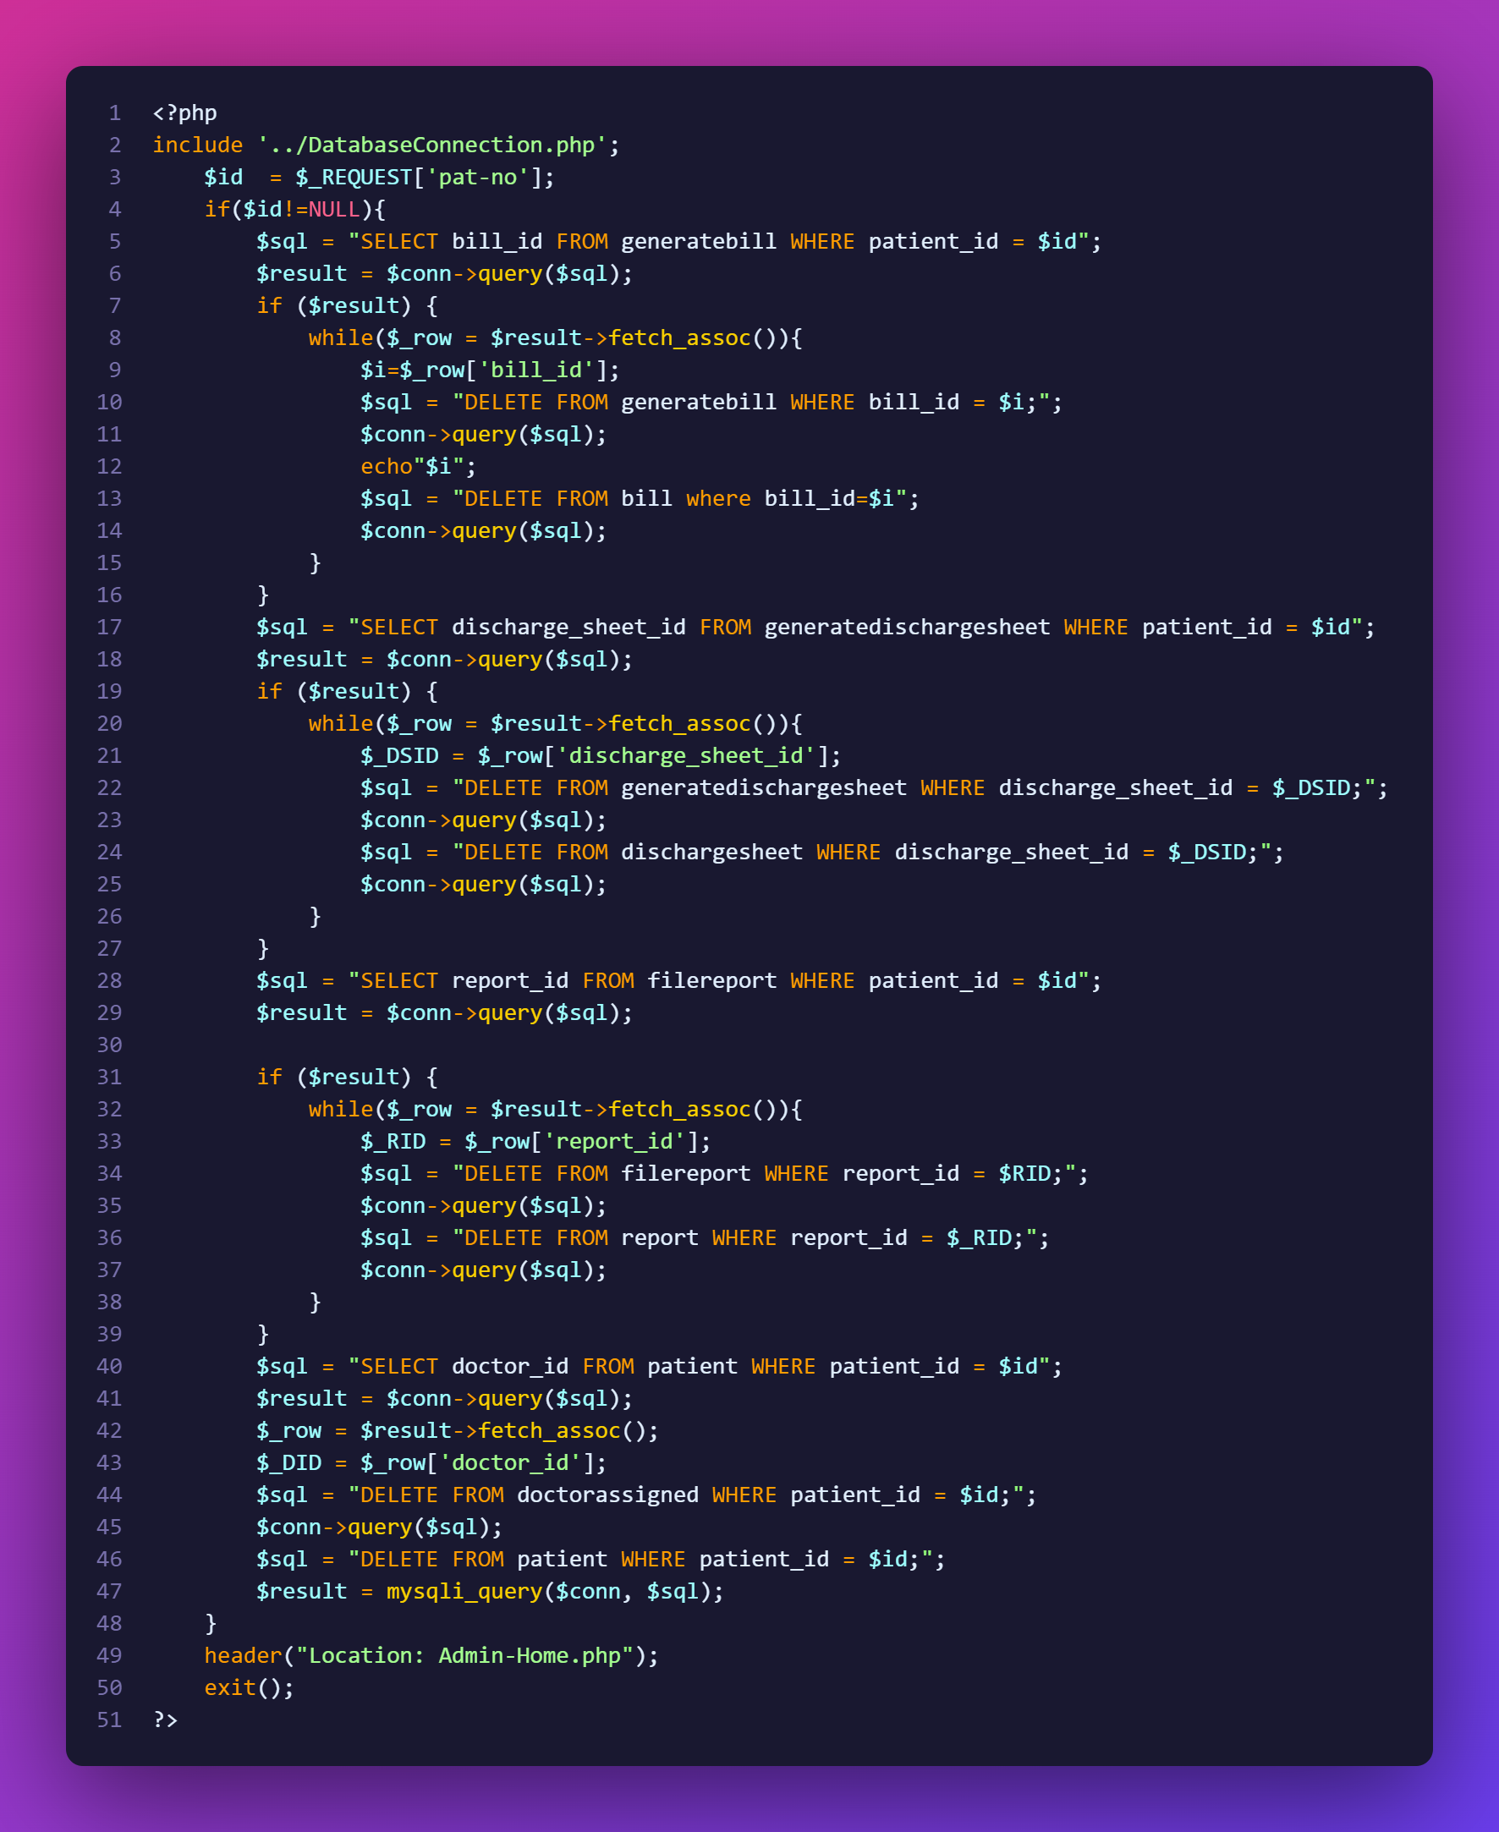

**Displaying Patients which are assigned to particular Doctor**

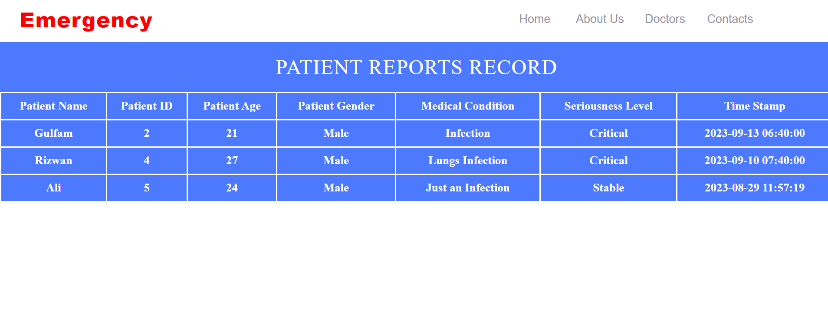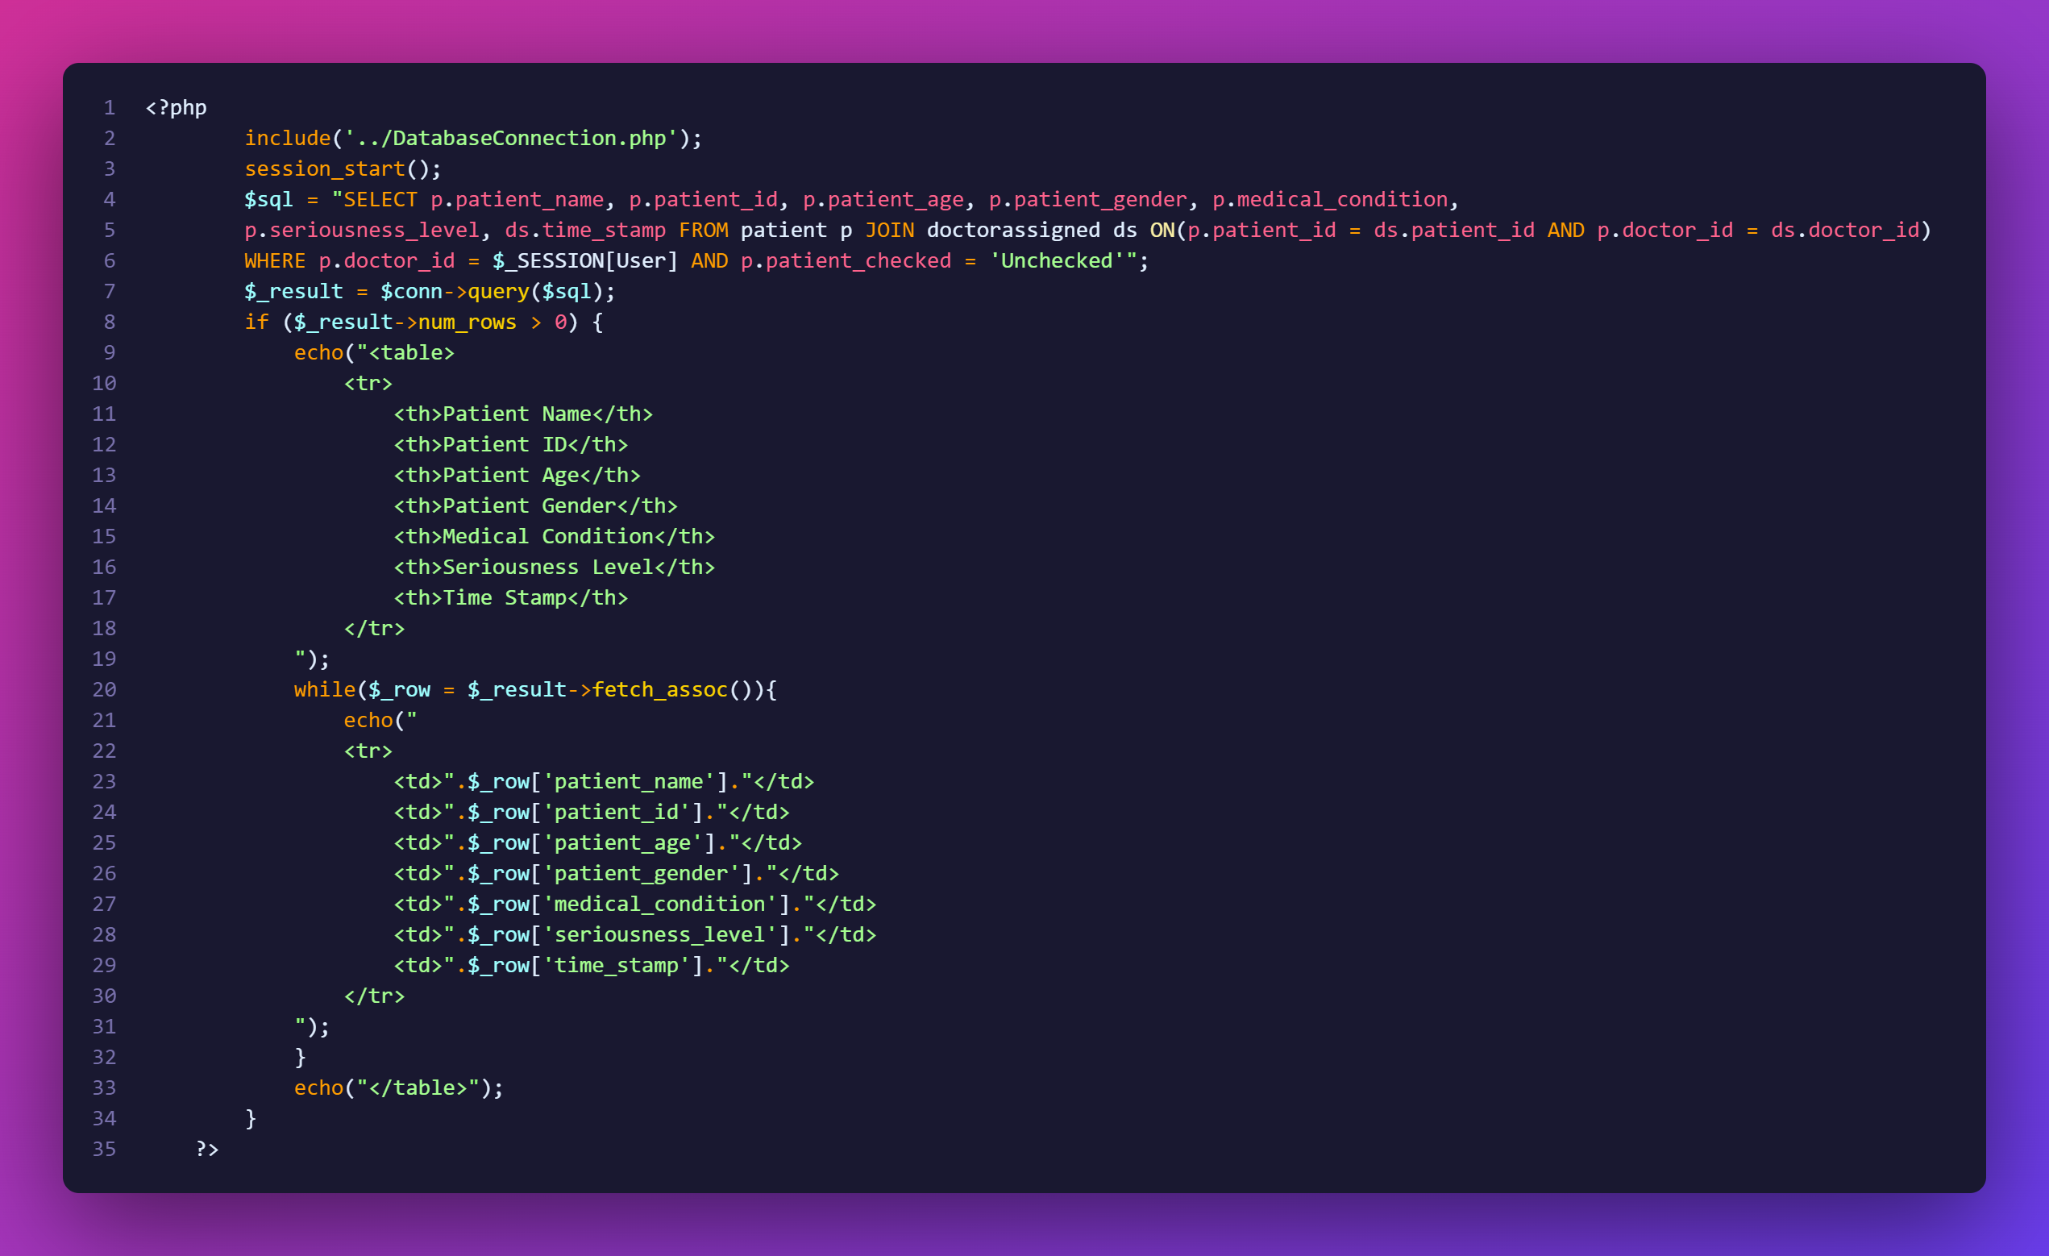

**Displaying Medical History of Patient to Doctor**

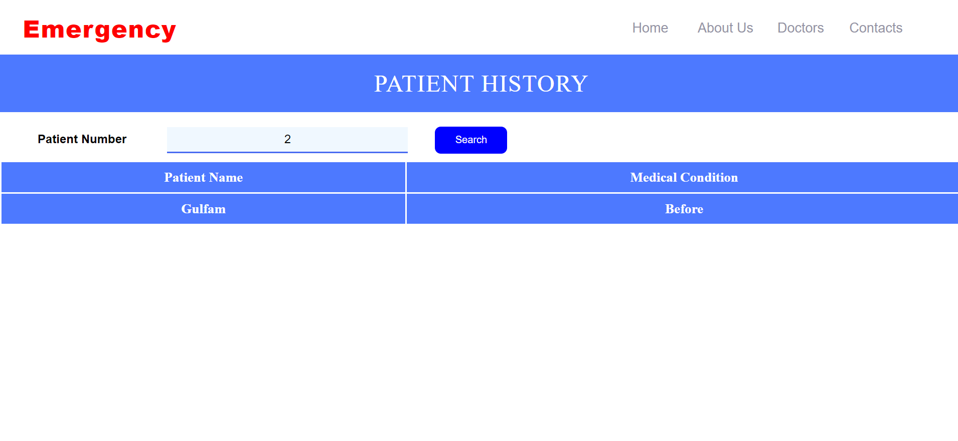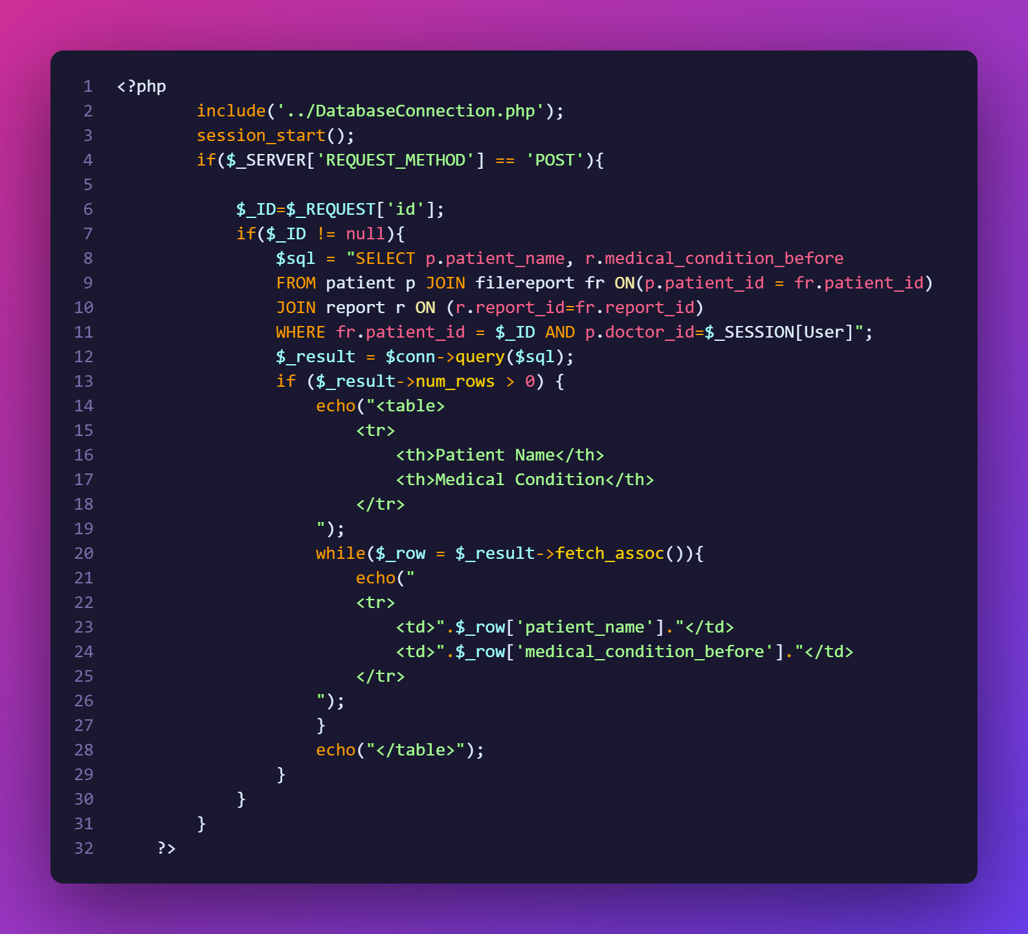

**Displaying particular Report of Patients which are assigned to Patient Care**

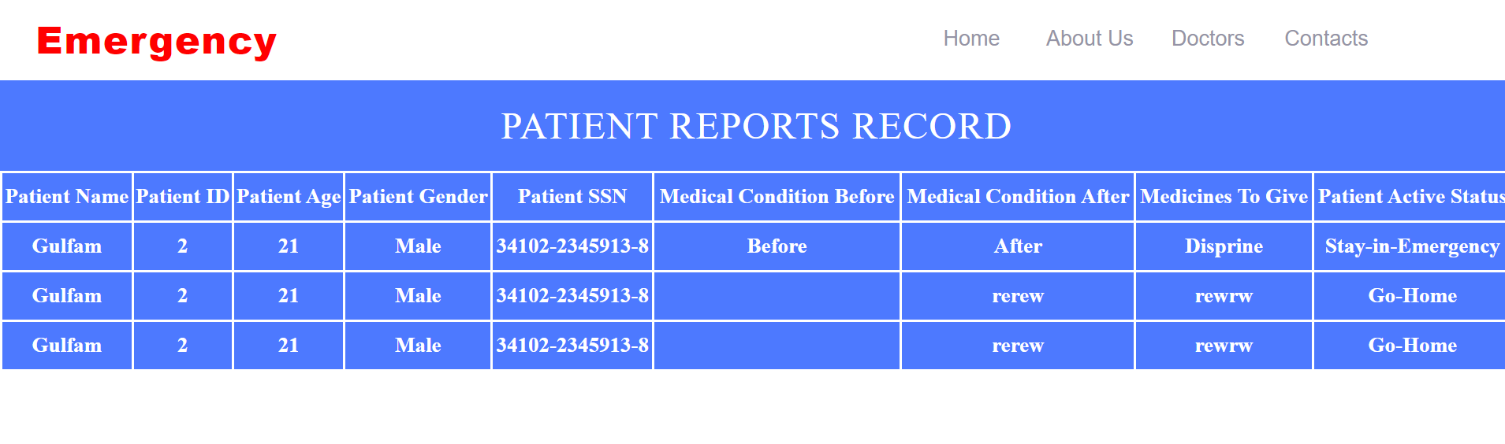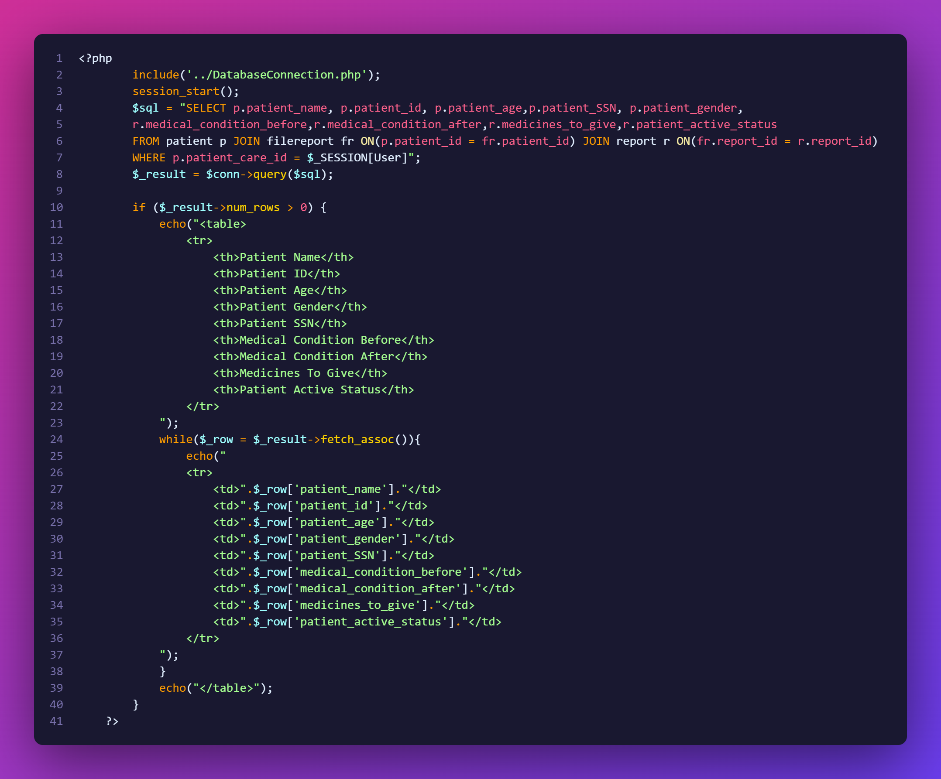

**Displaying particular Bill of Patients which are assigned to Patient Care**

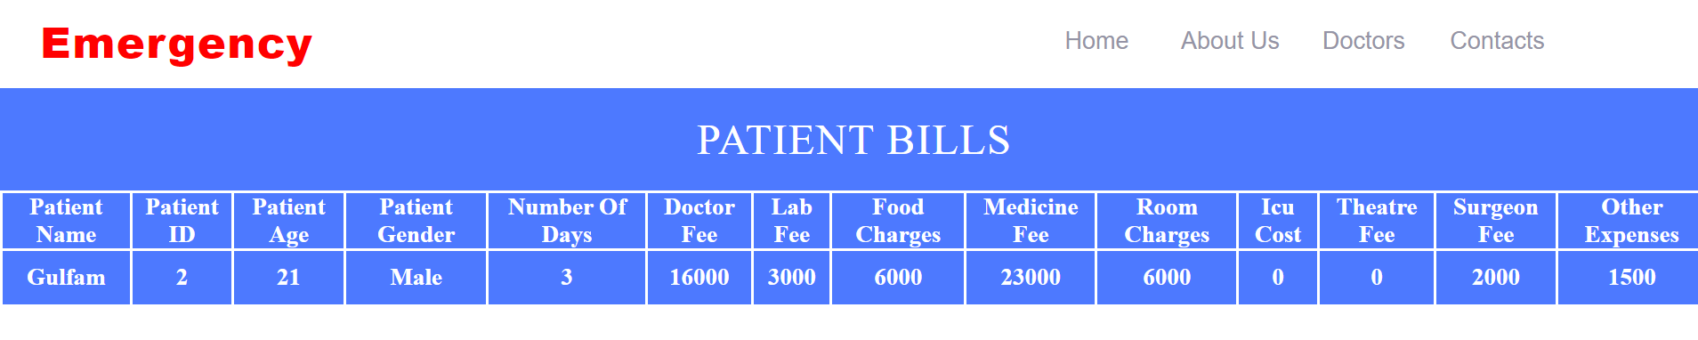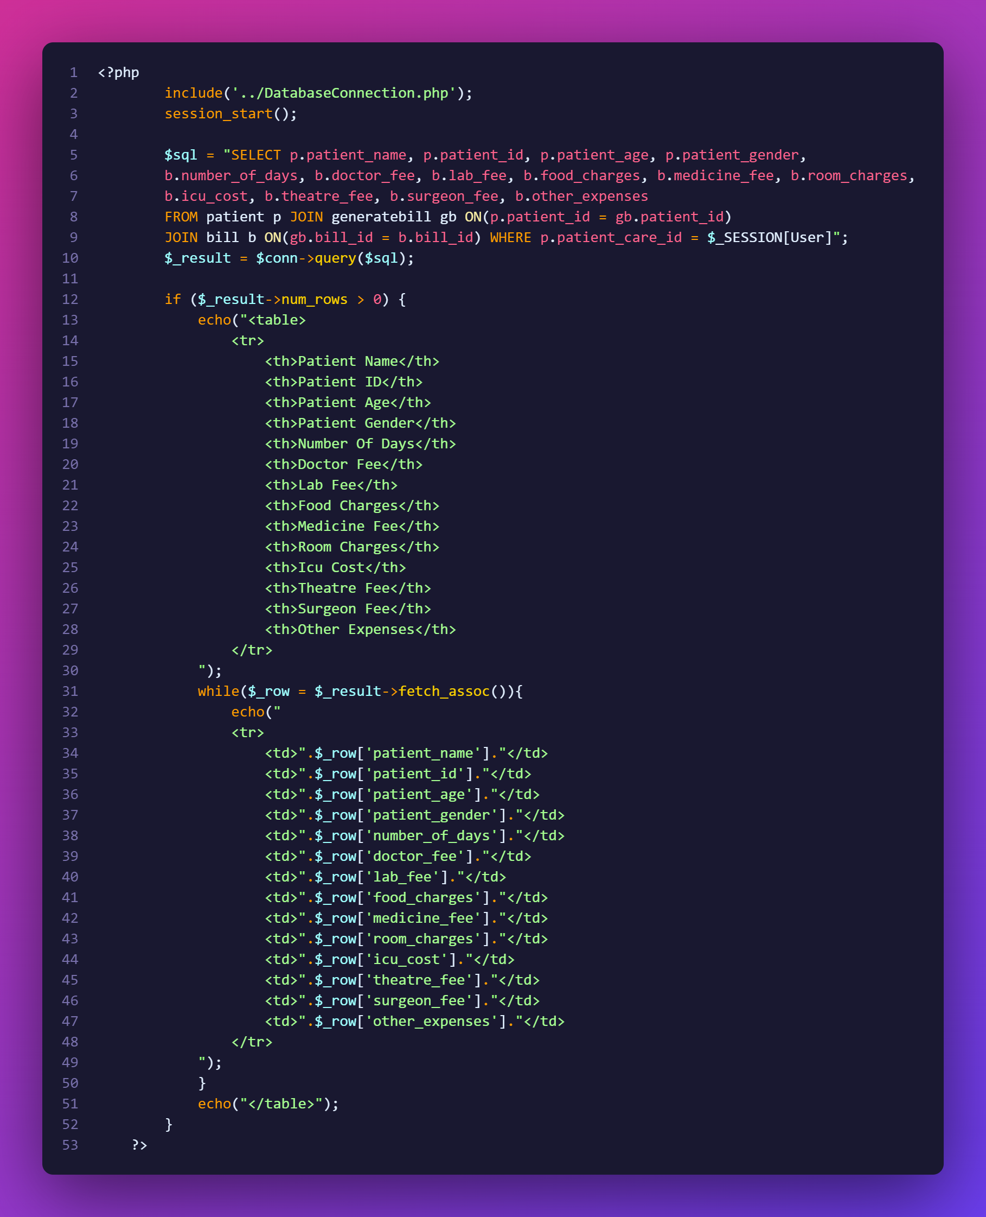

**Displaying particular Discharge Sheet of Patients which are assigned to Patient Care**

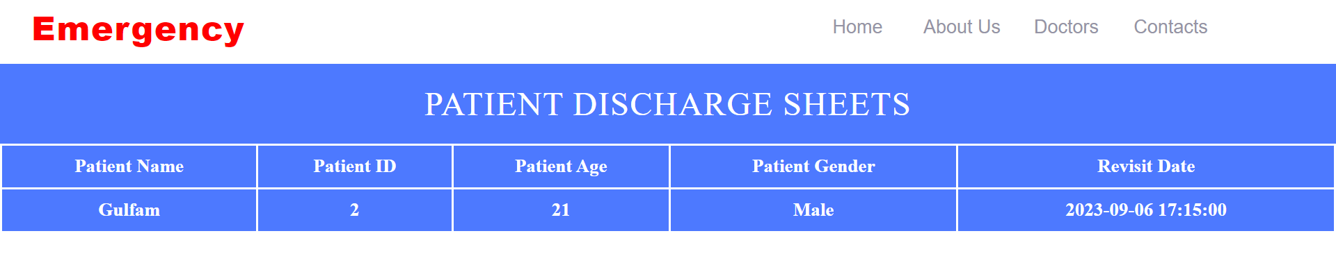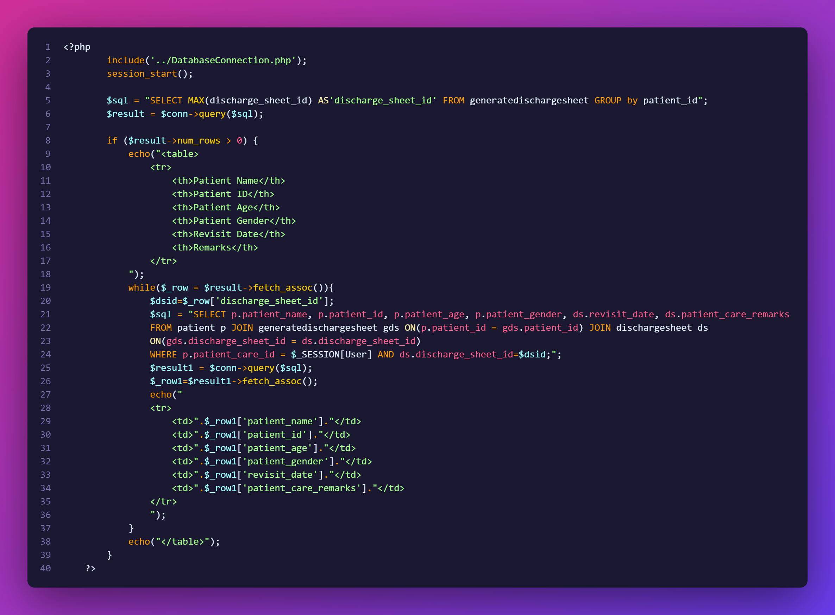

**Adding Remarks in Discharge Sheet of Patient which are assigned to Patient Care**

